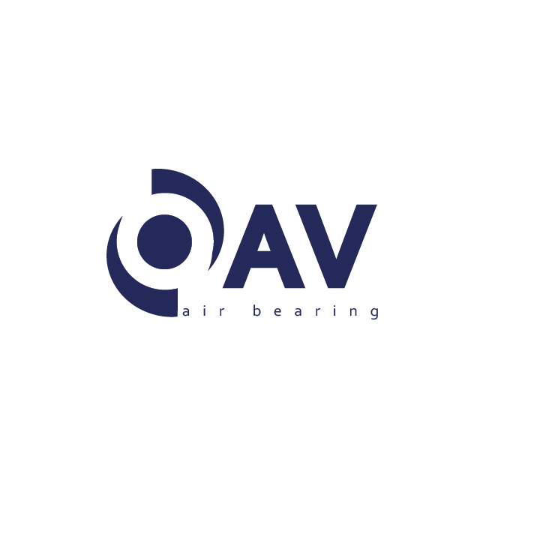

DISTRIBUTOR'S APPLICATION

* Company Name:
* Year Established:
* Full Address:
* Name of Managing Director:
* Name of Marketing Director:
* Phone:
* Fax:
* Email:
* Website:
* Do you have Branch Offices? (If yes please provide locations)
* Total number of Employees:
* Number of persons Engaged in Sales/Marketing:
* List of your Principles:

* Do you represent any lines that are Direct competition to OAV line?
* Do you participate in tradeshows? (If yes, How many a year?)
* Methods of Advertising:

* Your Marketing Budget:
* Describe your plan for introducing and Marketing OAV's ...

* Can you give us an estimate forecast for the OAV product line in your market?
* Do you purchase Demo Unit' s to support your sales plan?
* Do you normally hold stock?
* Describe your service facility/if any?
* Give us a description of your company's sales approach to a new product line?

* Describe your customer base:
* Please provide any other information you deam necessary to influence our decision.

